THRIFT FASHION

STORE

|  |  |
| --- | --- |
| documentation  This is a project for world’s Global Tech face-off. |  |

TEAM MEMBERS

***FRONT PAGE FREE BIRDS***

|  |  |
| --- | --- |
| STUDENT1363145 | KAINAT ASAD |
| STUDENT1359232 | SAYYEDA IEMAN NAVEED |
| STUDENT1336634 | MUHAMMAD SHAYAN Jani |
| STUDENT1347509 | ALISHBA |
| STUDENT1353088 | MOHAMMAD USAID AHMED |

PROJECT MENTOR: MISS QURATULAIN JIBRAN

Contents

INTRODUCTION: 6

PROBLEM DEFINITION 7

CASE STUDY 7

SYPNOSIS 8

HARDWARE & SOFTWARE REQUIREMENT 8

SCOPE OF THE WORK 9

ARCHITECTURE AND DESIGN OF THE SYSTEM 10

SITEMAP 11

TASK SHEET 12

LIST OF VALIDATION 13

SUBMISSION CHECKLIST 14

SCREEN SHOTS 16

# Introduction:

The thirst for learning, upgrading technical skills and applying the concepts in real life environment at a fast pace is what the industry demands from IT professionals today. However busy work schedules, far-flung locations, unavailability of convenient time-slots pose as major barriers when it comes to applying the concepts into realism. And hence the need to look out for alternative means of implementation in the form of laddered approach.

The above truly pose as constraints especially for our students too! With their busy schedules, it is indeed difficult for our students to keep up with the genuine and constant need for integrated application which can be seen live especially so in the field of IT education where technology can change on the spur of a moment. *Well,* technology does come to our rescue at such times!!

Keeping the above in mind and in tune with our constant endeavour to use Technology in our training model, we at Aptech have thought of revolutionizing the way our students learn and implement the concepts using tools themselves by providing a live and synchronous TECHWIZ learning environment!

# PROBLEM DEFINITION

This Web portal will be a responsive and visually appealing Website to be used by individuals. This portal will be designed to provide shopping process by considering the various problems faced by the customer.

# CASE STUDY

People often discard clothing items when they are no longer in use. They buy clothing from malls, online retail stores, or regular neighbourhood stores and later, when these clothes outgrow their utility, they throw them away or dump them in bins. This has even happened in the case of high-cost clothing. People who can afford expensive fashion typically do not like to repeat their outfits. They move on to buy newer items barely after using current items on two or three occasions. The older ones are then just discarded. This causes burden on the planet because as the number of such discarded fashion (which is still in good condition, nevertheless) increases, the effort to dispose them also increases.

These days, recycling, sustainability, and reuse are not just buzzwords, but actionable behaviours to support a better planet. Instead of discarding clothes that are still in good condition, but no longer required by the original buyers, these clothes can be sold as thrift fashion or pre-used clothing.

In simple terms, shopping for thrift fashion is second hand purchases for fashionable clothing.

This supports the theme of recycling and sustainability and is also affordable by many who otherwise could not purchase new fashionable clothing

# sypnosis

The proposed solution is a Website titled Thrift Fashion Store. It should help individuals with online shopping for second hand fashionable garments at affordable prices

Thrift Fashion Store provides an easy shopping facility for second hand clothing in excellent condition to the customers, wherein they can sit at one place and shop online anytime, anywhere 24/7.

# hardware & software requirement

# Hardware

* Intel Core i5 Processor
* 8 GB RAM
* Color SVGA 500 GB Hard Disk space
* Mouse
* Keyboard

# Software

Technologies to be used:

1. Frontend: HTML5, CSS3, Bootstrap 5, JavaScript, jQuery, Ajax)­­­­
2. Data Store: JSON/Text

# SOFTWARE USED

* Visual Studio Code

# scope of the work

Depending on the decision taken by the management regarding the thrift store, following are the requirements based on which the website must be developed.

1. The portal will be designed as a Single-Page-Application and responsive Website with a set of pages and menus that represent choice of activities to be performed. The pages, menus, and other visual elements must be designed in a visually appealing manner with attractive fonts, colors, and animations. All of these should also be laid out in a responsive manner.
2. **Home Page:** It will display menus such as Products, About Us, Contact Us, Feedback, and so on. A few featured products displayed with images and captions will be displayed on the home page. The home page should accept first name from the user and display a personalized welcome message. At the top corner, the user's first name should be displayed for the entire duration that the portal is loaded.
3. **Products:** This option will showcase the products one can order online via Thrift Fashion Store. Products can be displayed through an image gallery and can have product information such as availability, stock, price, discount (if any), product description, and so on.
4. **Find Product:** Using this option, users can search for a specific product that they are looking out for/of their interest.
5. **Checkout:** This should show the shopping cart contents and total bill based on product price and quantity of products purchased. You need not implement payment functionality; just list the cart contents and compute the bill.
6. **About Us and Contact Us:** This menu option should display Email id, address, and contact number of the organization who is developing the system. This acts like the Customer Care service, which is available 24/7 to the users in case of any query.

# architecture and design of the system



# sitemap

THRIFT STORE

CONTACT US

ABOUT US

PRODUCT

HOME

TOP TRENDING

MEN'S FASHION

MENS KURTA

DISCOUNT PRODUCT

PR

PR

WOMEN FASHION

MENS JEANS

SCARF COLLECTION

MENS CASUAL

KIDS FASHION

WOMEN WEAR

MENS COT

ACCESSORIES

KIDS CLOTHES

SHOES

KIDS SHOES

KIDS TOYS

# TASK SHEET

|  |  |  |  |  |
| --- | --- | --- | --- | --- |
| *s.no* | *task* | *Actual start day* | *When completed* | *status* |
| 01. | Case study | 10/8/2022 | 10/8/2022 | Completed |
| 02. | Material searching | 10/8/2022 | 10/8/2022 | Completed |
| 03. | Graphics  designing | 10/8/2022 | 11/8/2022 | completed |
| 04. | development | 11/8/2022 | 12/8/2022 | Completed |
| 05. | testing | 13/8/2022 | 13/8/2022 | Completed |
| 06. | documentation | 12/8/2022 | 12/8/2022 | completed |

# LIST OF VALIDATION

Some sample validation as follows:

|  |  |
| --- | --- |
| OPTION | VALIDATED |
| Do all text links to the appropriate web pages? | Yes |
| Do all images links to the appropriate web pages? | Yes |
| Are all the images and links clearly visible on the page? | Yes |
| Is the web page opening properly in all the tested web browsers? | Yes |
| Are the animations loading well? | Yes |
| Is the web page taking too long to load? | Not too long |
| Is the navigation sequences correct through all the web pages on the site? | Yes |
| Is the web page responsive? | Yes |
| Is the JavaScript coding working as expected in all click events? | Yes |

# submission checklist

|  |  |  |  |  |
| --- | --- | --- | --- | --- |
| *s.no* | *List of items* | *yes* | *no* | *comments* |
| 1 | Are all users able to view images and links? | √ |  |  |
| 2 | Have all composites of the website been integrated and do they load as expected? | √ |  |  |
| 3 | Is the GUI content devoid of spelling mistake? | √ |  |  |
| 4 | Is the portal user friendly? | √ |  |  |
| 5 | Is the website launching correctly in the browser? | √ |  |  |

# Screen shots

HEADER/NAVBAR

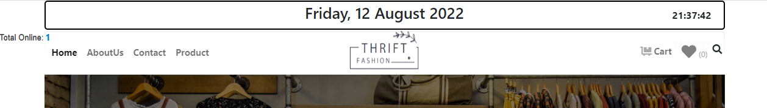

MAIN PAGE

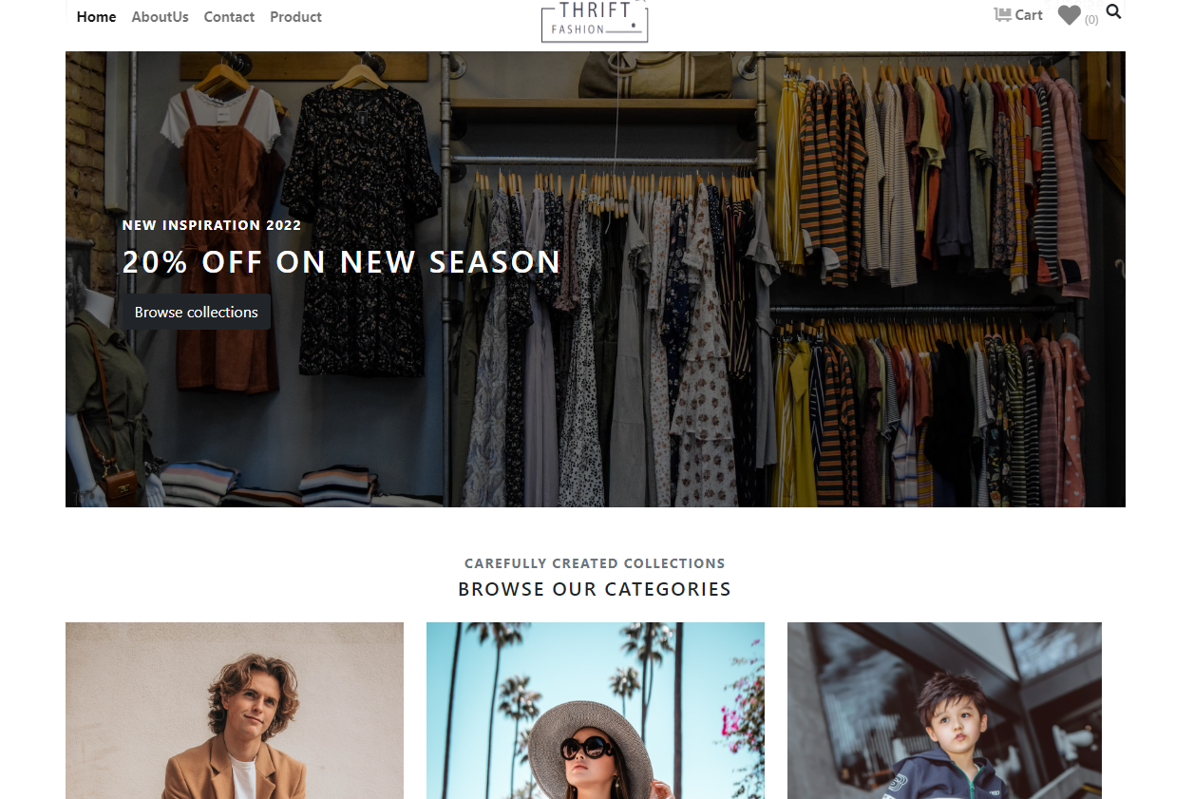

ABOUT US

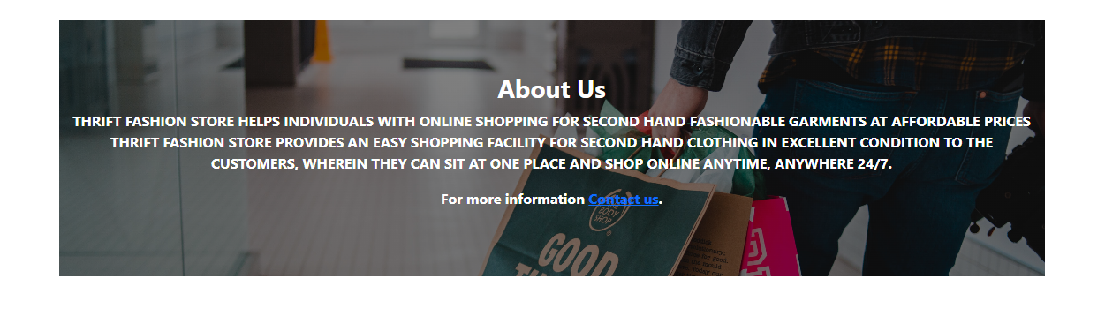

TRENDING PRODUCTS

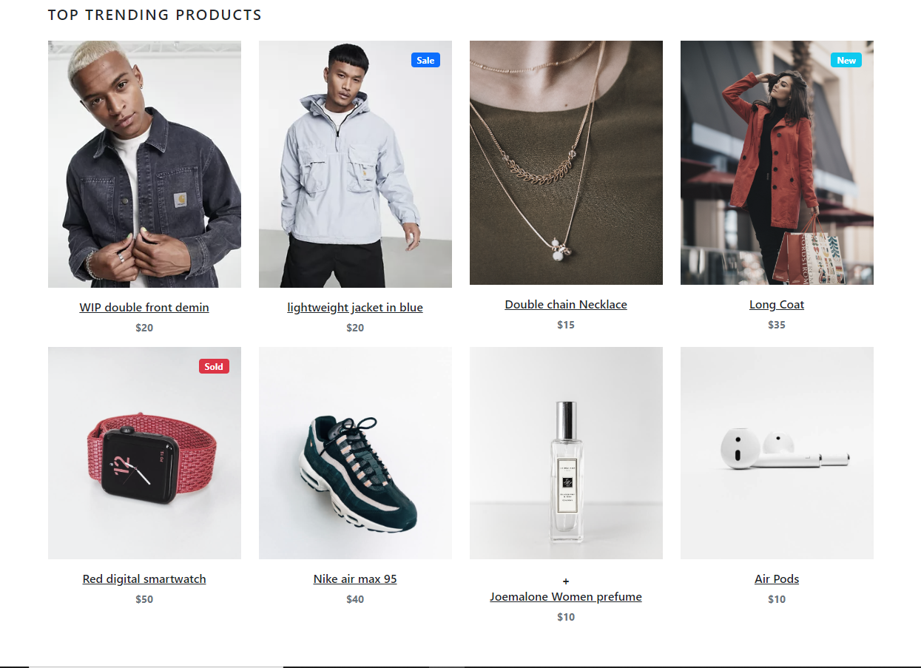

DISCOUNT OFFERS

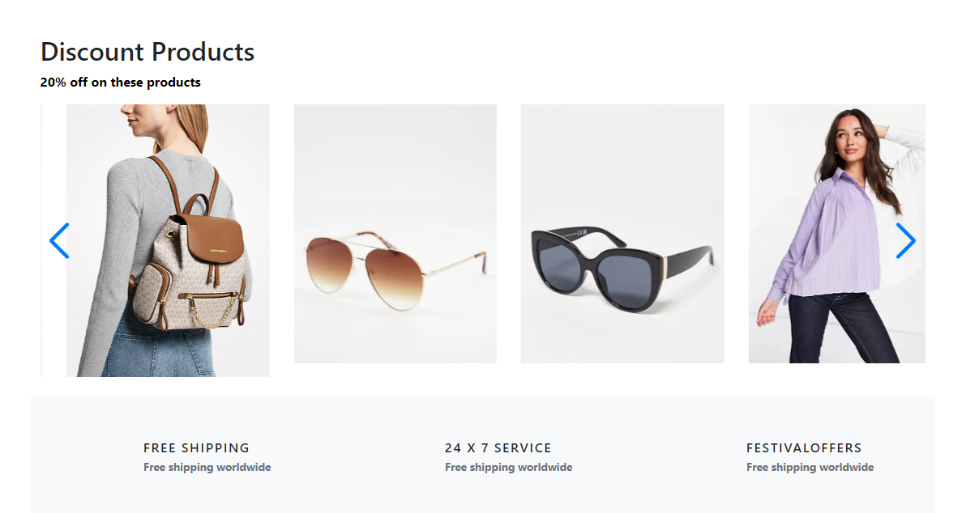

CONTACT US

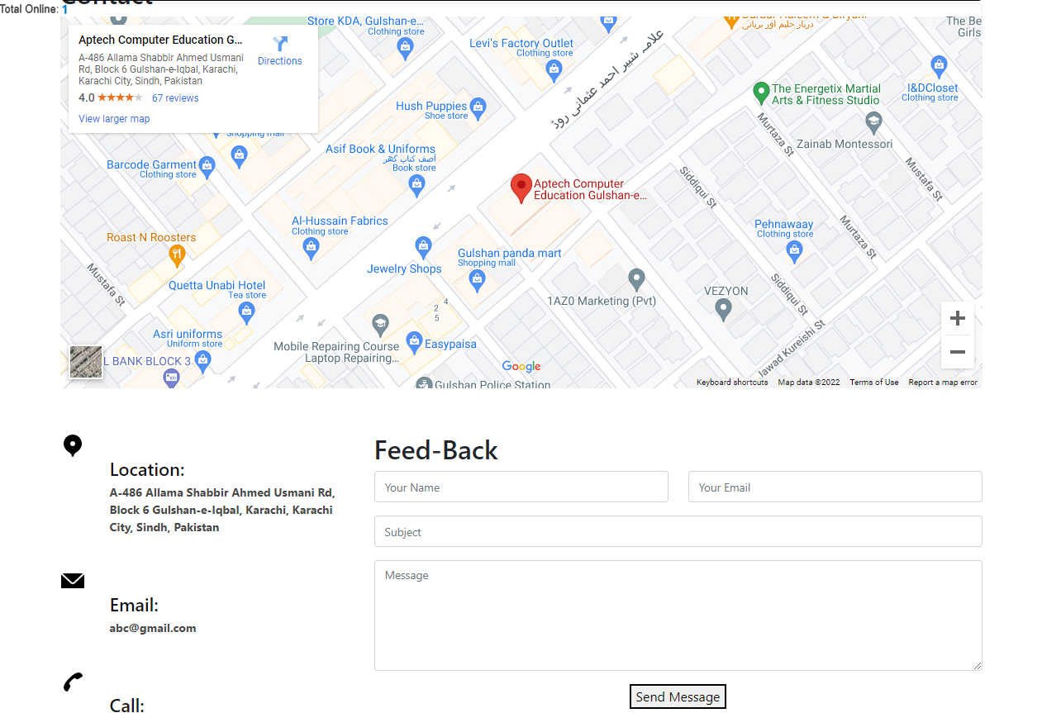

FOOTER

